Annual Report
2025
– Summary

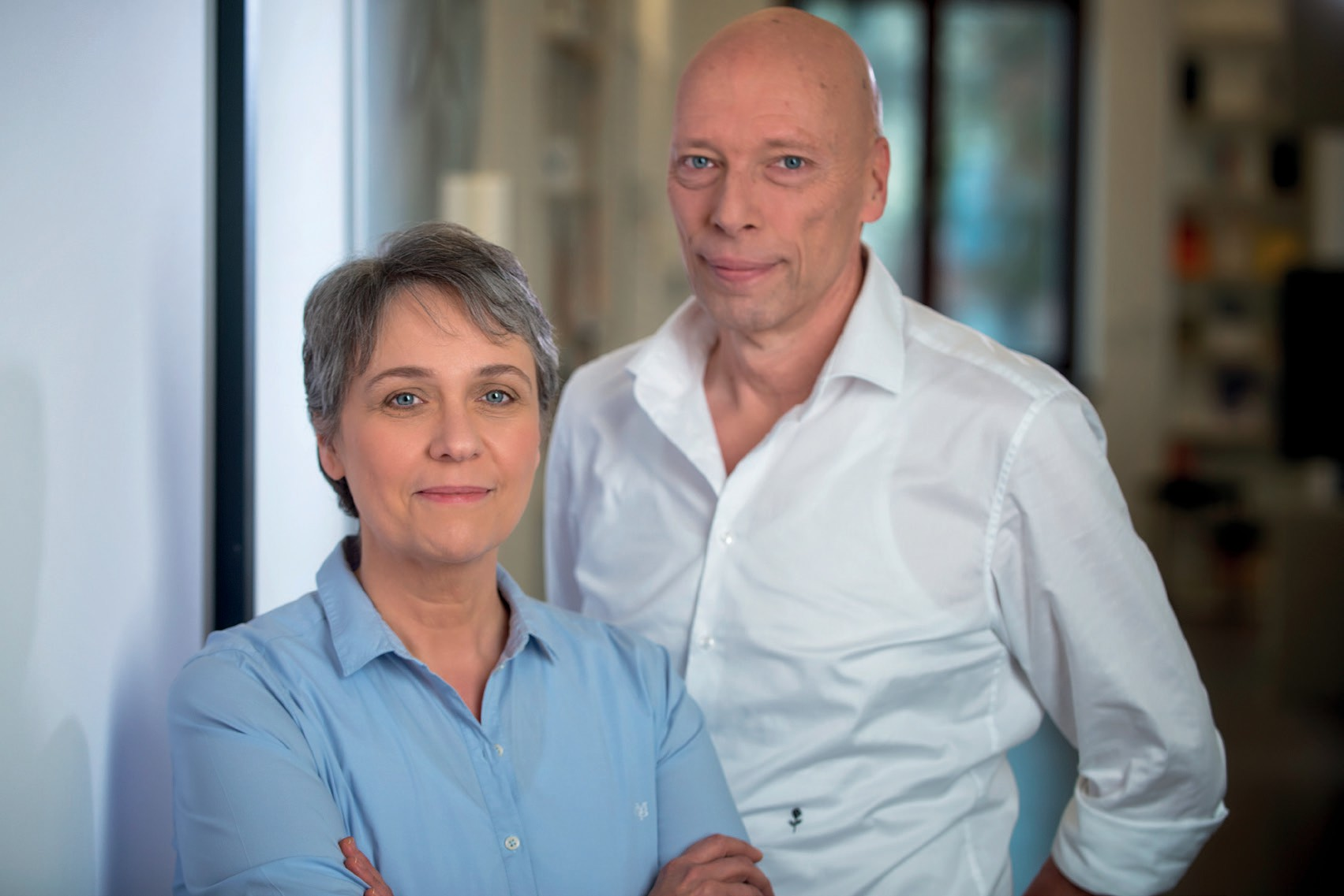
Judy Korn
Thomas Mücke

VISION
By preventing extremism, we strengthen democracy.

MISSION
We lay the foundations for people who are ideologically vulnerable or motivated by extremism to change their behaviour through disengagement work so that they act responsibly and become part of the democratic community. We provide them with tools and resources to help them reflect on and overcome their previous behaviour patterns. They are empowered to lead a life in which they harm neither themselves nor others.
We develop new approaches and methods for preventing extremism and engage with societal actors and political
decision-makers to create sustainable frameworks for combating extremism both online and offline.

2

REVIEW AND OUTLOOK

Democracy as a Duty
Annual Report 2025

The year 2026 will shape political education, the promo-tion of democracy and the prevention of extremism in Germany in the long term. The announced restructuring of the tried-and-tested federal programme “Demokratie leben!” (Live Democracy!), which has so far been un-rivalled internationally in terms of its scope and achievements, will bring about lasting changes to the landscape of democratic practice in Germany. It remains to be seen how the results achieved so far can be transferred and safeguarded, and it is to be hoped that Germany can maintain its pioneering role in this field, which is firmly established both in Europe and internationally.
Over the past few decades, a highly qualified and specialised prevention landscape has developed in Germany, which, in this form, serves as an international model. Violence Prevention Network is committed to the professional development of counselling services to help in deradicalisation and disengagement work, both in relation to specific phenomena and in general, as well as for stronger networking and effective synergies. In cooperation with other organisations, we have been making a unique contribution here for many years. In tertiary prevention in particular, exemplary collab-oration between organisations undertaking societal prevention work, academia and government bodies has been evident. This collaboration is crucial for successful deradicalisation work.
Funding programmes and their structure are decided at a political level and implemented by the administration; societal organisations work within these parameters, thereby fulfilling a democratically mandated role: they bring specialist expertise, counselling and community work to areas where government services alone often fail to achieve the same reach and impact.
Furthermore, beyond the funding policy landscape in Germany, the day-to-day work of those involved in pre-vention is repeatedly shaped by a succession of global crises, such as pandemic outbreaks, armed conflicts
or energy crises. Extremist actors exploit the resulting uncertainties and fears in society to win over young people, particularly with simplistic answers and promis-es of salvation.
Anti-democratic narratives are disseminated rapidly and widely via online social media platforms.
The urgently needed extremism prevention is currently taking place within this complex landscape, while the conditions under which it must prevail are becoming increasingly precarious. This is precisely why strength-ening and preserving democracy must remain our top priority, not least as a duty to future generations.
Judy Korn and Thomas Mücke July 2026

3

AT A GLANCE

184
Employees

11
Locations

44

Projects



6
Specialist
seminars 34
Publications



185

Workshops for schools
and youth support services



€10.4 million*

Resources deployed

*This is a provisional estimate,
which may be adjusted once the annual report's been finalised. 4

Annual Report 2025


296
Training
programmes for professionals

705

Group and individual
interventions within the prison service



121
Counselling
services for relatives


50
E-learning courses
(modules and workshops)

116

Counselling services


for institutions

198

Disengagement
support services
7,372

People reached through
our initiatives (total)
5

Lower Saxony

Thuringia
Hesse

Bavaria

Baden-Württemberg

Berlin

Brandenburg

Saxony

Hesse:
Hessian Counselling Centre – Pathways out of extremism
Hessian Counselling Centre – Intercultural competence
KOgEX Hessen 3.0 – Competence against extremism in prison and probation services

Lower Saxony:
Focus ISLEX – Mobile measures for prevention and deradicalisation within the Lower Saxony prison and probation services

Saxony:
Saxony Counselling Centre
Prisma Saxony – Identifying radicalisation, supporting deradicalisation, pooling expertise
FAIRhandeln – Developing practical skills for dealing
with racism targeting specific groups

Thuringia:
Thuringian Counselling Centre – Point of contact for the topics of Islamism and Islamophobia in Thuringia

Nationwide:
Working Group of the Prison and Probation Services
DeSBa – De-escalation and self-protection in counselling work
dist[ex] – Development of a Network for

WHERE WE WORK

Projects in the federal states (selection): Baden-Württemberg:
PräWo Justiz – a workshop series within the prison service for young prisoners at risk of radicalisation

Bavaria:
Bavarian Counselling Centre

Berlin:
Berlin Counselling Centre – Pathways out of extremism
Prevent Berlin 2.0
CROSSROADS – Exiting from right-wing extremism
proRespekt Specialist Centre – Shaping non-violent schools democratically
JUST X Berlin – Prevention and deradicalisation in Berlin’s prison and probation services
REE! – A change of course for right-wing extremists

Brandenburg:
EXchange Brandenburg – Mobile initiatives for prevention and deradicalisation in prison and probation services
Disengagement and Exit work
PrEval – Evaluation designs for prevention measures RADIS – Research into the societal causes and effects of radical Islam in Germany and Europe
From Confrontation to Dialogue – Constructive conversations in the neighbourhood

Online:
EAS – E-learning on the prevention of antisemitism for migrants
EXchange Brandenburg Digital
Gaming and right-wing extremism – How right-wing extremists misuse gaming platforms
GaRex – Countering hate speech effectively
JUST X Berlin Digital
Thuringian Prison Service Compass
Net Heroes 60+
PRISMA Saxony Digital
Further development of prevention and counselling on conspiracy ideology in connection with extremist views

As of: 2025

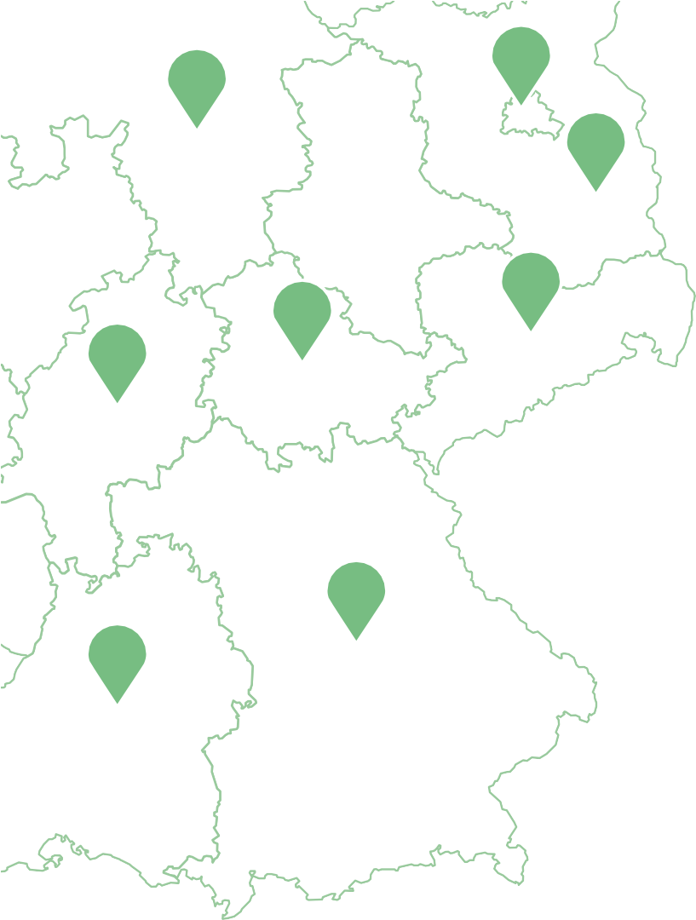
6


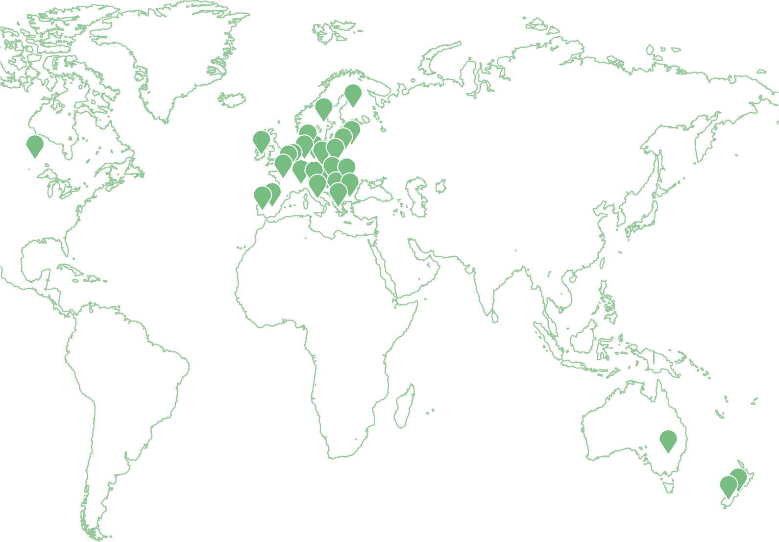

International Projects:
European Union and the Western Balkans
- EOOH – European Observatory of Online Hate (EU)
- EU Knowledge Hub on the Prevention of Radicalisation (EU)
- PARTESS-COM (EU)
- Persuasive AI Chatbot for Counter-Extremism: A value-sensitive multi-stakeholder feasibility study (Austria, EU)
- TRACE (Poland, Hungary, the Czech Republic and Slovakia)

North America
- DIVERSIONS – Canada (Canada)

Oceania
- CCAN – Christchurch Call Advisory Network (New Zealand)
- DIVERSIONS – Australia
- DIVERSIONS – New Zealand

Worldwide
- INDEX – International Network for Disengagement and Exit
As of: 2025

7

Legal Notice
Violence Prevention Network gGmbH
Judy Korn, Thomas Mücke - Management Team Alt-Reinickendorf 25
13407 Berlin
Tel.: (030) 917 05 464
Opens link to: post@violence-prevention-network.de Opens link to: www.violence-prevention-network.de
Registered in the Commercial Register at the Berlin-Charlottenburg District Court
under the Company Registration Number: HRB 221974 B
© Violence Prevention Network 2026
Image credits: Violence Prevention Network/fotoploetz Typesetting/Design/Graphics: Dimo Gugutschkow (Tapetenwechsel Leipzig) Donations are always welcome!
Donation account:
Bank für Sozialwirtschaft
IBAN: DE18 3702 0500 0001 1188 00 BIC: BFSWDE33XXX
Or online via our form at: Opens link to: www.violence-prevention-network.de

Opens link to: www.linkedin.com/company/violence-prevention-network
Visit our blog: Opens link to: www.interventionen.blog

